SIMATS ENGINEERING
ASSESSMENT TOOL 1

COURSE NAME: Database Management Systems COURSE CODE: CSA05

COURSE OUTCOME COVERED

CO2: Apply the relational model, relational algebra, SQL query structures, and views to solve database querying and data manipulation problems. (BL3, BL6)

Activity Tool : Analytical Problem Solving (High) Assessment Tool Weightage: 35%

Dr

QUESTIONS Total Marks: 50
Q.No | Question | Bloom's Level | Marks
1 | Apply relational algebra operations (σ, π, ∪, -, ×, ⋈ ) on the given Employee and Department relations to retrieve required records. | BL3 – Apply | 5
2 | Write SQL DDL statements to create STUDENT(SID, Name, DOB, DeptID) and DEPARTMENT(DeptID, DeptName) tables with all appropriate constraints. | BL3 – Apply | 5
3 | Formulate SQL queries using GROUP BY, HAVING, and aggregate functions (COUNT, SUM, AVG, MAX, MIN) on a given Sales dataset. | BL3 – Apply | 5
4 | Write a correlated sub-query to find employees earning more than the average salary of their own department. | BL3 – Apply | 5
5 | Apply all types of JOIN operations (INNER, LEFT OUTER, RIGHT OUTER, FULL OUTER, CROSS) on Employee and Project tables. | BL3 – Apply | 5
6 | Create a view 'DeptSalaryView' that displays department name, total employees, and average salary. Write a query on this view. | BL6 – Create | 5
7 | Construct a relational algebra expression for the following: Find names of students who are enrolled in all courses offered. | BL6 – Create | 5

8 | Write SQL DML statements (INSERT, UPDATE, DELETE) with integrity constraint enforcement for a given scenario. | BL3 – Apply | 5
9 | Apply tuple relational calculus to express a query: Find all employees who work in the 'IT' department and earn more than 50000. | BL3 – Apply | 5
10 | Design a relational schema for an Airline Reservation System and write 5 SQL queries demonstrating joins, sub-queries, and views. | BL6 – Create | 5

Code of Conduct:

(Mohanarangan.s/192511439)(Name / Reg No) certify that this submission is my original work and that I have adhered to the guidelines specified for this assessment. I understand that any violation of academic integrity rules will result in disciplinary action.
Mohanarangan.s
Signature of the student:

RUBRICS FOR CALCULATION:

Numerical Problems
Criteria | Weightag e | Level 4 (Exemplary) | Level 3 (Proficient) | Level 2 (Developing) | Level 1 (Beginning)
Problem Understandin g | 20% | Clearly interprets problem, identifies all parameters and  requirements accurately | Understands problem with minor gaps | Partial understanding  ; misses key elements | Misinterprets or unable to understand problem
Method Selection | 20% | Selects most appropriate method/formul a with strong justification | Selects correct method with minor errors | Inappropriate or partially correct method | Unable to select method

Solution Process | 25% | Logical, systematic steps with correct approach  throughout | Mostly correct steps with minor mistakes | Disorganized steps; multiple errors | No clear process
Accuracy of Calculation | 20% | All calculations accurate; correct final  answer | Minor calculation errors | Frequent errors; incorrect final  answer | No valid calculations
Interpretation of Results | 15% | Clearly interprets results with units and engineering  relevance | Basic interpretatio n with minor omissions | Limited or unclear interpretation | No interpretatio n

1Q)
create database companydb; use companydb;

create table department( deptid int primary key, deptname varchar(30), location varchar(30)
);

create table employee( empid int primary key, empname varchar(30), salary int,
deptid int,
foreign key(deptid) references department(deptid)
);

insert into department values (101,'hr','chennai'),
(102,'it','bangalore'),
(103,'finance','mumbai');

insert into employee values (1,'rahul',45000,101),
(2,'sneha',60000,102),
(3,'arjun',55000,102),
(4,'priya',40000,103),
(5,'karan',70000,101);

select * from department; select * from employee;

select * from employee where salary>50000;
select empname,salary from employee; select deptid from employee
union
select deptid from department;

select deptid from department
where deptid not in(select deptid from employee);

select * from employee cross join department;

select e.empid,e.empname,e.salary,d.deptname,d.location from employee e
inner join department d on e.deptid=d.deptid;

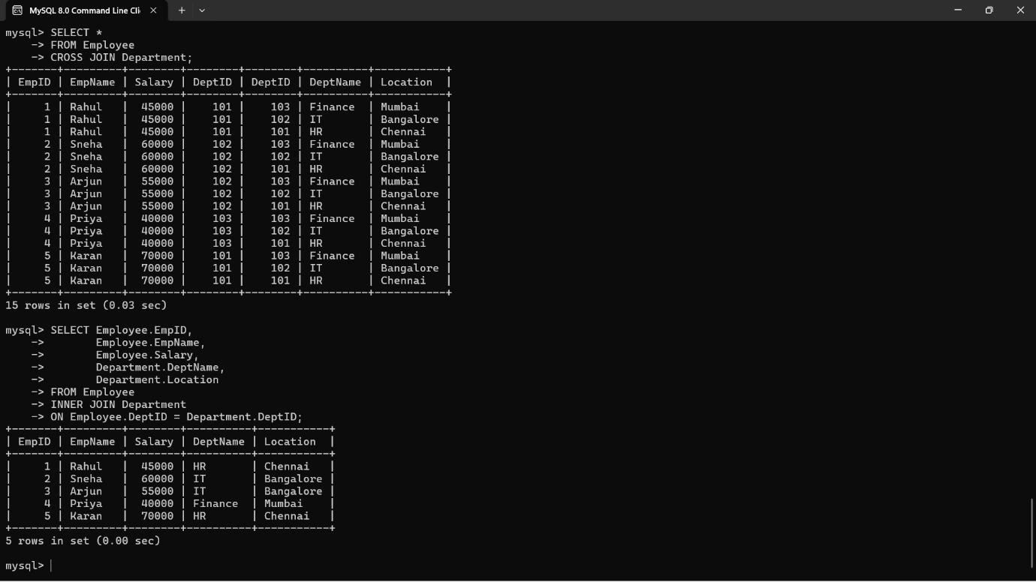
OUTPUT:
2Q)
create database collegedb; use collegedb;

create table department( deptid int primary key,
deptname varchar(30) not null unique
);

create table student( sid int primary key,
name varchar(30) not null, dob date not null,
deptid int,
foreign key(deptid) references department(deptid)
);

desc department;


desc student; OUTPUT:

3Q)
create database salesdb; use salesdb;

create table sales( saleid int primary key,
productname varchar(30), category varchar(20), quantity int,
price int
);

insert into sales values (1,'laptop','electronics',2,50000),
(2,'mouse','electronics',5,500),
(3,'keyboard','electronics',3,1000),
(4,'chair','furniture',4,3000),
(5,'table','furniture',2,7000),
(6,'pen','stationery',20,20),
(7,'book','stationery',10,150); select * from sales;
select category,count(*) totalproducts from sales

group by category;

select category,sum(quantity) totalquantity from sales
group by category;

select category,avg(price) averageprice from sales
group by category;

select category,max(price) highestprice from sales
group by category;

select category,min(price) lowestprice from sales
group by category;

select category,sum(quantity) totalquantity from sales
group by category having sum(quantity)>5;

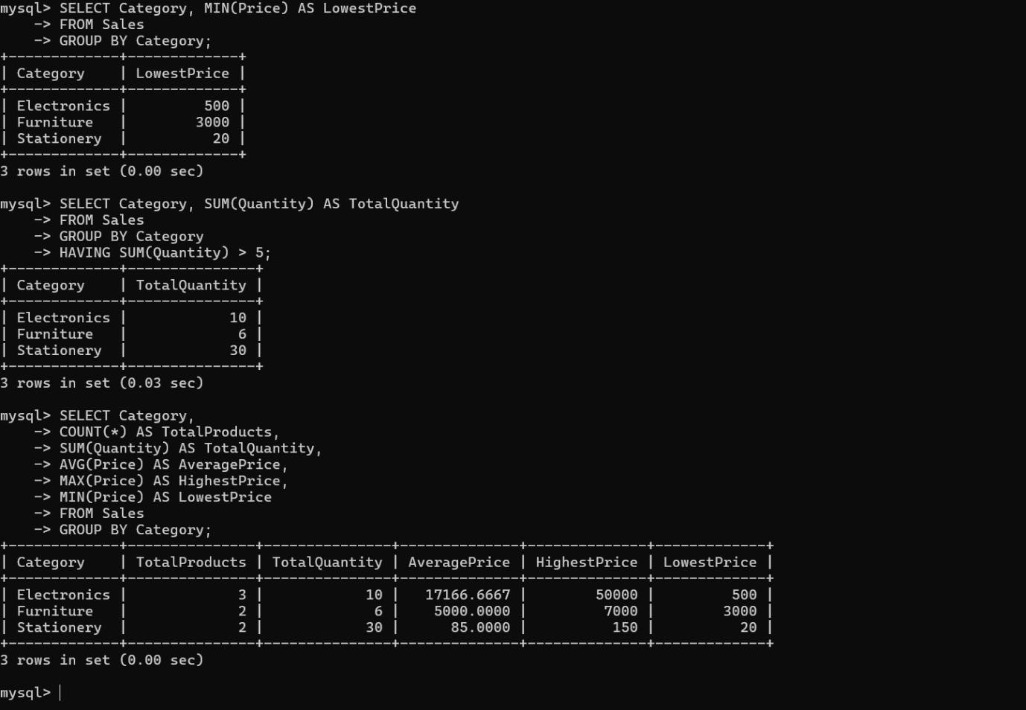
OUTPUT :

4Q)
use companydb;

select empid, empname, salary, deptid
from employee e1 where salary>
(
select avg(salary) from employee e2
where e1.deptid=e2.deptid
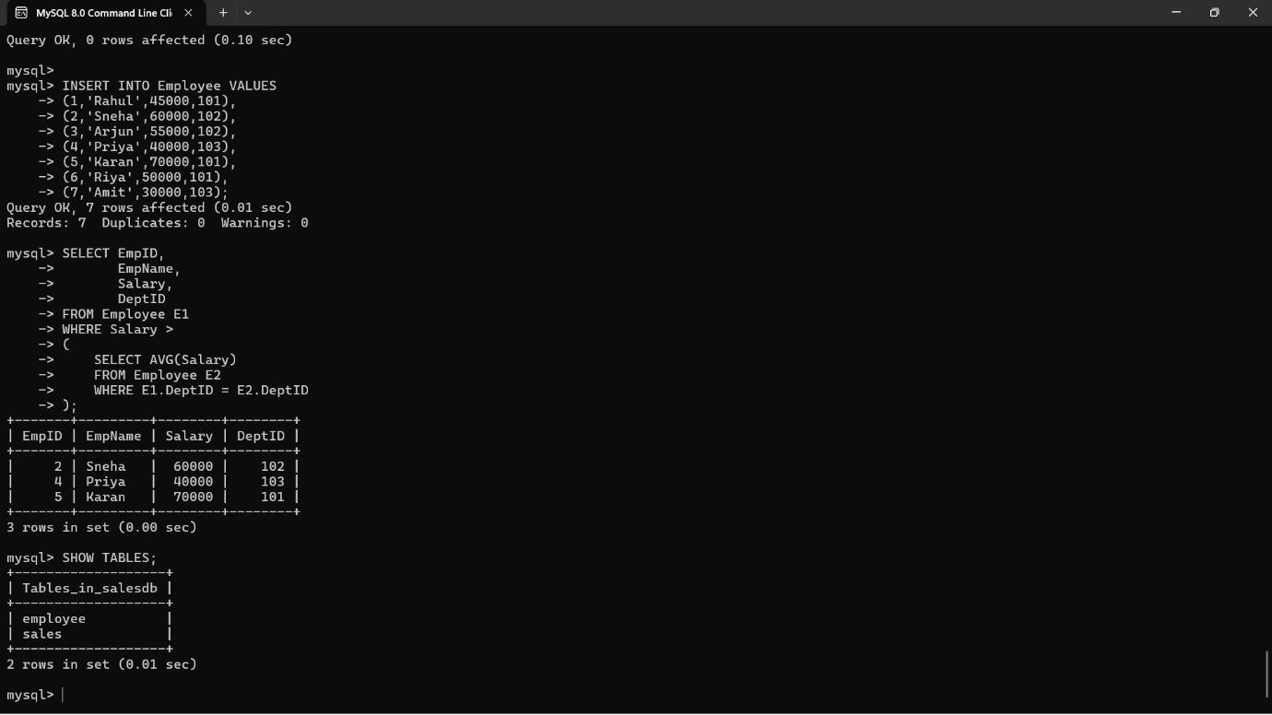
); OUTPUT :

5Q)
use companydb;

create table project( projectid int primary key, projectname varchar(30), deptid int
);

insert into project values

(1,'website',101),
(2,'mobile app',102),
(3,'payroll',103),
(4,'ai system',104);

select * from employee; select * from project;

select e.empid,e.empname,p.projectname from employee e
inner join project p on e.deptid=p.deptid;

select e.empid,e.empname,p.projectname from employee e
left join project p
on e.deptid=p.deptid;

select e.empid,e.empname,p.projectname from employee e
right join project p
on e.deptid=p.deptid;

select e.empid,e.empname,p.projectname from employee e
left join project p
on e.deptid=p.deptid union
select e.empid,e.empname,p.projectname from employee e
right join project p
on e.deptid=p.deptid;

select *
from employee cross join project;

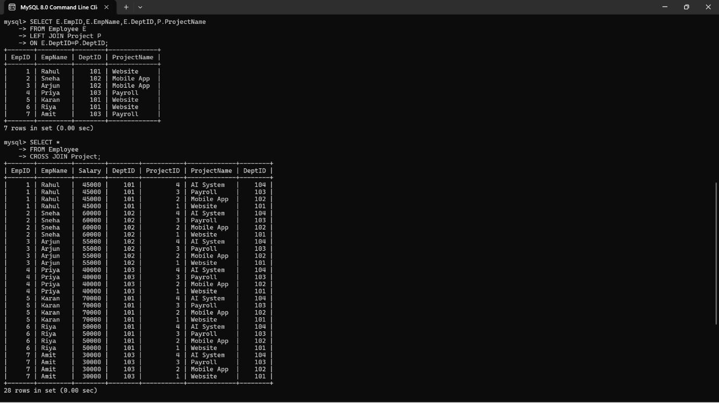
OUTPUT :
6Q)
use companydb;

create view deptsalaryview as select d.deptname, count(e.empid) as totalemployees, avg(e.salary) as averagesalary from department d
join employee e
on d.deptid=e.deptid group by d.deptname;

select * from deptsalaryview;

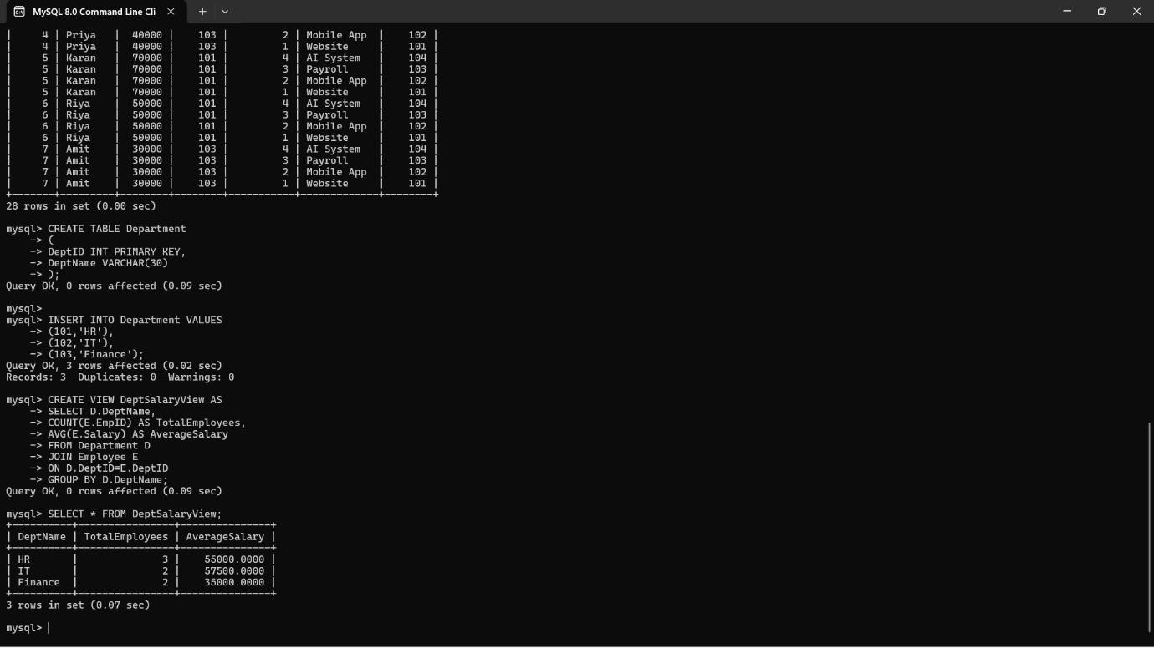
OUTPUT :
7Q)
create database studentdb; use studentdb;

create table student( sid int primary key, name varchar(30)
);

create table course( courseid int primary key, coursename varchar(30)
);

create table enrollment( sid int,
courseid int,
primary key(sid,courseid),
foreign key(sid) references student(sid),
foreign key(courseid) references course(courseid)
);

insert into student values (1,'rahul'),
(2,'sneha'),
(3,'arjun');

insert into course values (101,'dbms'),
(102,'java'),
(103,'python');

insert into enrollment values (1,101),
(1,102),
(1,103),
(2,101),
(2,102),
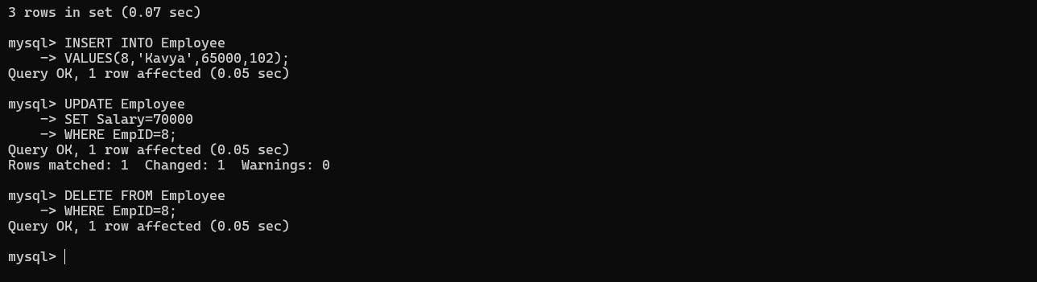
(3,101); OUTPUT :

8Q)
use companydb;

insert into employee values(6,'riya',50000,102);
select * from employee; update employee
set salary=65000
where empid=6;

select * from employee;

delete from employee where empid=6;

select * from employee;

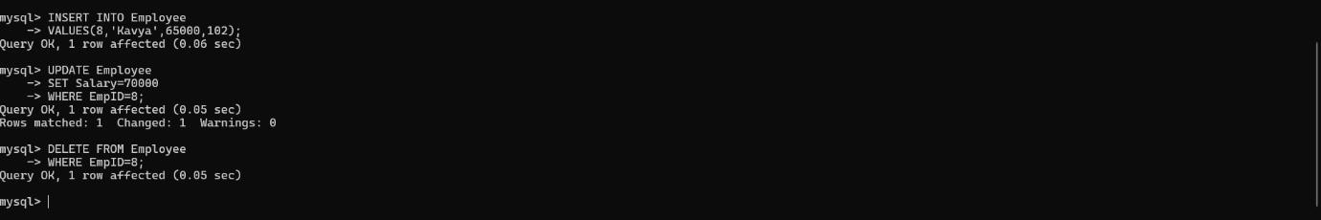
OUTPUT :
9Q)
use companydb;

create table department1( deptid int primary key, deptname varchar(30)
);

insert into department1 values (101,'hr'),
(102,'it'),
(103,'finance');

select * from employee; select * from department1;

select e.empid, e.empname, e.salary, d.deptname from employee e
join department1 d on e.deptid=d.deptid
where d.deptname='it' and e.salary>50000;

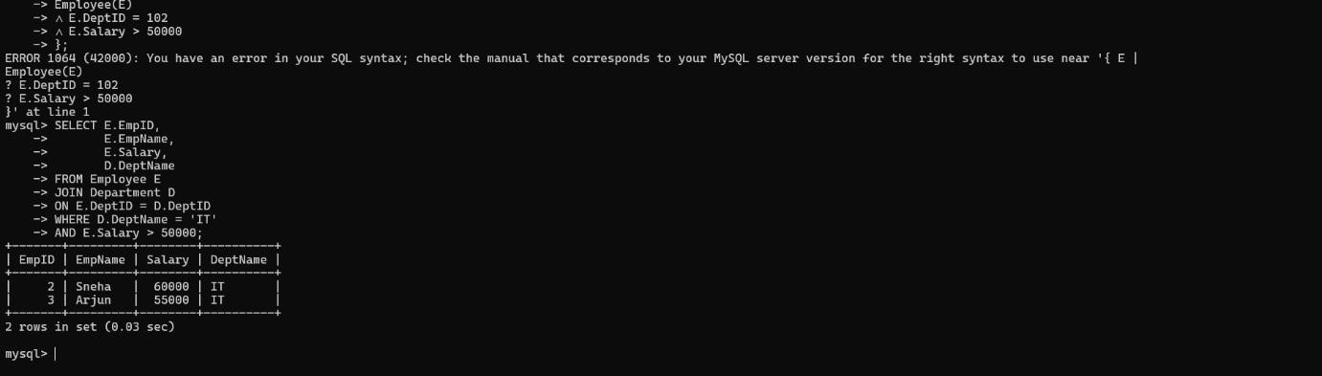
OUTPUT :
10Q)
create database airlinedb;

use airlinedb;

create table passenger( passengerid int primary key, passengername varchar(30), phone varchar(15)
);

create table flight( flightid int primary key, flightname varchar(30), source varchar(30), destination varchar(30)
);

create table booking( bookingid int primary key, passengerid int,
flightid int, journeydate date,
foreign key(passengerid) references passenger(passengerid), foreign key(flightid) references flight(flightid)
);

insert into passenger values (101,'rahul','9876543210'),
(102,'sneha','9876543211'),
(103,'arjun','9876543212'),
(104,'priya','9876543213');

insert into flight values (201,'air india','chennai','delhi'),
(202,'indigo','bangalore','mumbai'),
(203,'spicejet','hyderabad','kolkata');

insert into booking values (301,101,201,'2026-08-10'),
(302,102,202,'2026-08-11'),
(303,103,203,'2026-08-12'),
(304,104,201,'2026-08-13');

select * from passenger; select * from flight; select * from booking;

select passengername,flightname from passenger p
join booking b
on p.passengerid=b.passengerid join flight f
on b.flightid=f.flightid;

select passengername from passenger
where passengerid in (
select passengerid from booking
);

select flightname,passengername from flight f
join booking b
on f.flightid=b.flightid join passenger p
on p.passengerid=b.passengerid;

create view flightbookingview as select passengername,flightname from passenger p
join booking b
on p.passengerid=b.passengerid join flight f
on b.flightid=f.flightid;
select * from flightbookingview; select flightid,
count(*) as totalbookings
from booking group by flightid;

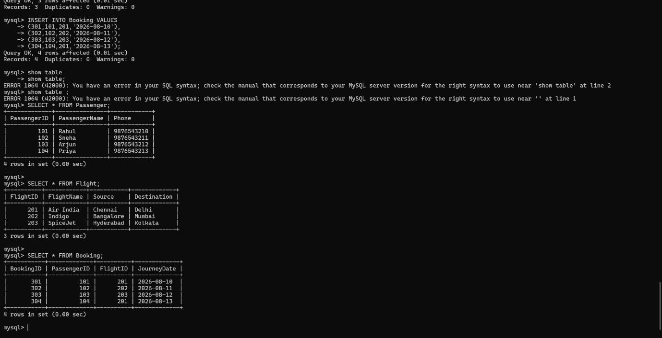
OUTPUT :

